**[Ticinolive](https://www.ticinolive.ch/)**

Italian-speaking Swiss newspaper

**The second Italian Spiritual Counseling Conference, by Cristina T. Chiochia**

 SEP 19, 2022  by [Cristina Chiochia](https://www.ticinolive.ch/tag/cristina-chiochia/), [cultura](https://www.ticinolive.ch/tag/cultura-2/" \t "_blank)

The second conference on Spiritual Counseling with the evocative title of "Born to love" was held in Milan with great success, with participants coming from all over Italy on Saturday 17 September in the Aula Magna of the Higher Institute of Religious Sciences. Hosted by the Higher Institute of Religious Sciences of Milan, in collaboration with the Milan Insight School of Higher Education along with the support of the Graduate School of Religion & Religious Education of Fordham University, NY, and with the participation of Archbishop Mario Delpini of Milan, the conference was organized by Prof. Barbara Marchica. The conference offered an access key to enhance one's own process of spiritual as well as inner awareness. Starting from the approach of the Canadian theologian Bernard Lonergan, the second conference (the first took place in 2018) offered a choice of interventions, by the scientific director, Prof. Marchica, who guided the conference as a sort of journey in counseling with the initial aim of paying attention to oneself and facilitating greater awareness with others. The conference addressed the practice of spiritually-oriented counseling which in Italy, unfortunately, is not as recognized because counseling is considered more as psychological practice. All the more reason to focus on spiritually-oriented counseling, a category yet to be fully discovered in Italy. But to explain what counseling is, and in particular spiritually-oriented counseling was certainly the important speech at the conference by prof. Kirk Bingaman of Fordham University in New York.

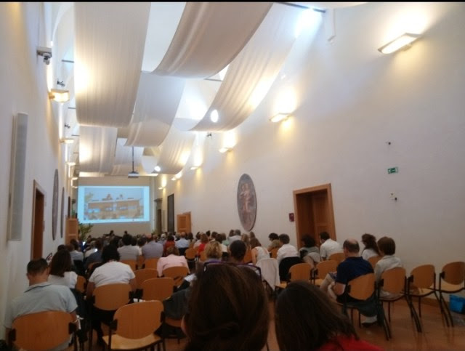

So, is psychology and spirituality therefore possible together? Certainly, another interesting aspect that has been explored in the many testimonies of both consecrated and non-consecrated course participants, how interventions and training can offer a new key to understanding self and society. During the conference, Prof. Marchica traced the profile of a concrete experience of six months of spiritual counseling in a Milanese parish, presenting ideas and reflections of the parish reality of today in Italy.

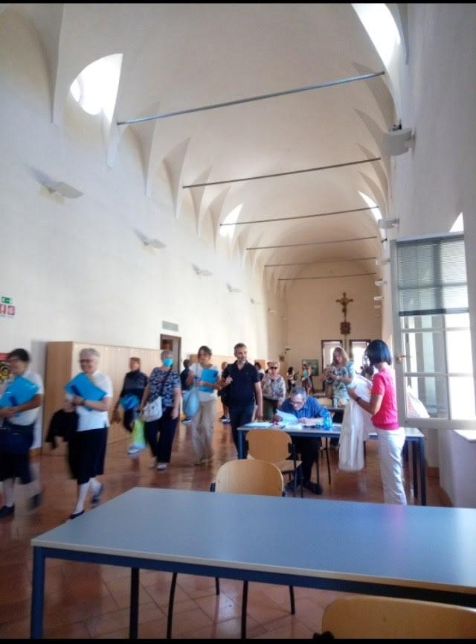

What makes, perhaps, spiritual counseling in Italy difficult to predict as a category is that it is automatically linked exclusively to psychology. But spiritually-oriented counseling demonstrates that this is possible, certainly due to the profound sense of becoming aware of the dynamics of one's inner world, as well as of one's choice to be oneself more authentically. During the conference, one certainly had the sense of experiencing "something" profound, maybe what intuition often only suggests but with the practice of spiritual counseling can be made more knowable. With spiritual counseling, you try to draw conclusions about yourself, without judging yourself. What to do at that point? What, in short, is the value of this method? Can you really choose the right path with spiritual counseling? Who knows? But in general, knowing more about yourself with counseling, spiritual and otherwise, is possible. Deep down, spiritually-oriented counseling is about improving one's relationships with self, others, the Divine through universal love and compassion.