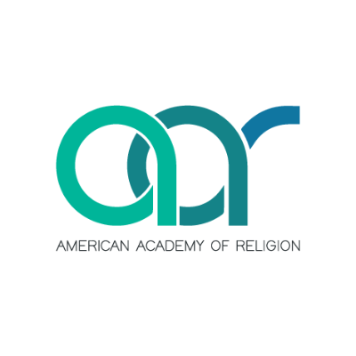
{Dr. Kirk Bingaman was a panelist for the following session of the Psychology, Culture, and Religion Group at the recent meeting of the American Academy of Religion. His presentation focused on, “AI won the first round with social media: Reflections on what comes next, and the implications for educators, care providers, and faith communities”}

American Academy of Religion Annual Meeting, San Diego, CA
Friday, November 22, 2024

Psychology, Culture, and Religion Group
Theme: Professional Development Workshop: Reflections on Emergent AI Technologies and the Practices of Teaching, Care, and Counseling
Kirk A. Bingaman, Fordham University
Kelly Bulkeley, The Sleep and Dream Database, Presiding
Jaco Hamman, Vanderbilt University

Facilitated by long-time PCR members Kirk Bingaman, Kelly Bulkeley, and Jaco Hamman, this workshop aims to stimulate greater critical awareness of practical issues in psychology and religion prompted by the rise of artificial intelligence (AI) technologies. Initially framed by three different perspectives on the practical use and future potentials of AI, the workshop will center on small-group discussions of several key questions: What cultural values and norms are being built into AI systems? How does human agency and subjectivity change when engaging with AI? What kind of transference relationship is formed when people seek answers, guidance, or companionship from AI? What role can/will AI play in practices of therapy and counseling? As we enter another era of social disruption driven by rapid, seemingly irreversible technological advances, is it possible to balance the creative use of these tools with a forceful critique of their dangers?

